|  |  |  |  |
| --- | --- | --- | --- |
| **M** **INISTRY OF EDUCATION AND TRAINING**  **H** **O CHI MINH CITY OPEN UNIVERSITY**  **D** **EPARTMENT OF INFORMATION TECHNOLOGY**  -------------------------------------------    **F** **INAL PROJECT REPORT**  **SUBJECT: MOBILE PROGRAMMING**  **T** **OPIC: ONLINE MOVIE STREAMING APPLICATION**  **Team 2**   |  |  |  | | --- | --- | --- | | |  |  | | --- | --- | | 2051012061  2051012105  2051010304  2051010201  2051012083 | Phạm Đức Mạnh  Mai Nhật Thanh Tâm  Lê Thị Ngọc Thư  Hoàng Quảng Ngà  Bùi Văn Nin | |   **Instructor: M.S Lê Ngọc Hiếu**  **Ho Chi Minh City, August 2023** |

# **Introduction**

Welcome teacher and friends, this is the report on Online Movie App made by our team..

First of all, we would like to express our our heartfelt gratitude to Professor M.S Le Ngoc Hieu. We appreciate the valuable knowledge and experiment you have imparted to us, as well as creating the best conditions for all of us to undertake this project.

Our movie app was born with the goal of providing the best entertainment experience for users.We understand the importance of entertainment in daily life and aim to offer everyone an opportunity to relax and enjoy the unique world of cinema. The app allows users to access a diveser collection of movies from a variety of genres, from drama to comedy and from cartoons to sci-fi movies. Users can watch movies anytime, anywhere. Watching movies and engaging in entertainment helps reduce stress, bring joy, provide moments of relaxation, and uplift the spirit.

The implementation of a project related to our coursework and the application of various knowledge has helped us gain a deeper and more comprehensive understanding of the subject

However, due to lack of experience, the application still cannot avoid shortcomings. We hope that our teacher can provide feedback and advice so that we can improve in future projects. We sincerely appreciate your guidance.

**TABLE OF CONTENTS**

**Introduction** 1

**LIST OF FIGURES** 3

**LIST OF TABLE** 5

**I. Technical and professional description** 6

**1.** **Purpose of application** 6

**II. DIRECTION FOR USE** 14

**1.** **Login & Signup account:** 14

**2.** **Homepage:** 19

**3.** **Searching** 21

**4.** **Upcoming** 23

**5.** **Ranking** 26

**6.** **Favorite List** 27

**7.** **Watching Movie** 29

**III. SHORTCOMINGS AND APPLICATION DEVELOPMENT DIRECTIONS** 36

**IV. LIST OF TEAMS AND ASSIGNMENTS** 37

**V. SUMMARY** 38

# 

# **LIST OF FIGURES**

*Figure I.2.1: How to build app* 9

*Figure I.2.2: How to build app* 9

*Figure I.2.3: How to build app* 10

*Figure I.2.4: How to build app* 10

*Figure I.2.5: How to build app* 11

*Figure I.2.6: Login Facebook Error* 11

*Figure I.2.7: Our team firebase* 12

*Figure II.1.1: How to access User page* 15

*Figure II.1.2: How to Login/Signup account* 15

*Hình II.1.3: Giao diện Đăng nhập/Đăng ký* 16

*Figure II.1.4: When login successful* 17

*Figure II.1.5: Logout* 18

*Figure II.1.6: Logout* 19

*Figure II.1.7: User screen when logout successfully* 19

*Figure II.2.1: Homepage* 20

*Figure II.2.2: Featured movie page* 21

*Figure II.2.3: Movies on same genre* 21

*Figure II.3.1: How to enter Search* 22

*Figure II.3.2: how to search* 22

*Figure II.3.3: Search results in the search bar* 23

*Figure II.3.4: Show movies by theirs genre* 24

*Figure II.4.1: How to access Upcoming* 25

*Figure II.4.2: Upcoming screen* 25

*Figure II.4.3: How to Share upcoming movie* 26

*Figure II.4.4: How to Share upcoming movie* 26

*Hình II.4.5: Hướng dẫn lưu bộ phim sắp ra mắt* 26

*Figure II.5.1How to access Ranking screen* 27

*Figure II.5.2: Ranking screen* 27

*Figure II.5.3: How to save movie from Ranking screen* 27

*Figure II.6.1: How to find your favorite list* 28

*Figure II.6.2 Empty favorite list* 29

*Figure II.6.3: List after being add* 29

*Figure II.7.1: This is when you click to watch a movie.* 31

*Figure II.7.2: The basic information about movie* 31

*Figure II.7.3: The basic information about movie after expand* 31

*Figure II.7.4: Movie’s genres* 32

*Figure II.7.5: Swipe to see more genres* 32

*Figure II.7.6: Save, Share, add to Favorite list features* 32

*Figure II.7.7: Save, Share, add to Favorite list features* 32

*Figure II.7.8: Share* 32

*Figure II.7.9: The related movies* 33

*Figure II.7.10: Trailer* 34

*Figure II.7.11: YouTube customization options* 35

*Figure II.7.12: Player basic funtions* 35

*Figure II.7.13: Fullplay mode* 36

*Table IV.1: Tables assignment* 38

# 

# 

# **LIST OF TABLE**

Bảng IV.1: Bảng phân công 36

# 

# **I. Technical and professional description**

## **Purpose of application**

This application was created with the aim of providing attractive titles in a variety of genres so that users can comfortably watch the movies and programs whenever and wherever they want.

Combined with that, there are features and utilities aimed at providing the best experience for users when enjoying the movies..

1. **Technical Description and Operations**

The project is built upon the **MVVM (Model-View-ViewModel)** architecture: It is a software architectural pattern commonly used in mobile and web application development to separate the data layer (Model), user interface (View), and provide an intermediary layer (ViewModel) to manage interactions between them.

The user interface is built using Jetpack Compose: It is a user interface (UI) development framework developed by Google for mobile and tablet applications running on the Android platform. It provides a new way to build user interfaces in Android applications using Kotlin-based syntax, instead of XML as was done previously.

The application logic is constructed using the Kotlin programming language, utilizing Coroutines to handle asynchronous tasks.

The Database used is **Firebase**, which managing data within the application, it offers a range of cloud service for app development, include**:**

* **Firebase Cloud Firestore:** Firestore is a real-time database that provides a more flexible data structure, organized into collections and documents
* **User Authentication:** Firebase offers user authentication services through **Firebase Authentication**. This allows you to manage user lists, authenticate via email, phone numbers, social media, and support custom authentication methods..

**The libraries used in project:**

* **Dagger Hilt:** Provides a convenient and user-friendly approach for implementing Dependency Injection.
* **ExoPlayer:** Serves as the app's player for audio and video content playback.
* **Coil-kt**: Used for efficient image loading and display
* **Moshi JSON:** Employed for parsing and serializing JSON data.
* **Youtube Player:** Integrated for viewing YouTube videos within the app.
* **Facebook SDK**: Integrated for sharing and connecting with the Facebook.
* **Firebase Auth KTX**: Facilitates the management of Firebase user authentication in a more user-friendly manner.
* **Kotlin SDK**: The Kotlin programming language for the application's development.

**Function of mavigation between screens (navigation)**

Implemented using the Android Navigation library, which help esay navigation between different parts of app and data transfer between screens using Parcelable.

**Functon Login**

**!Warning:** To use login functionality you need to build app version **Release (**release mode**)**  and need some minor configurations.

**Step 1: Choose to build variants**

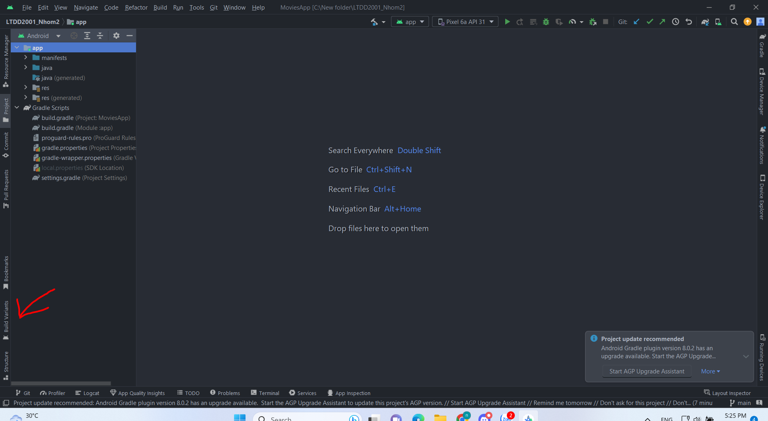

### *Figure I.2.1: How to build app.*

**Step 2:** Click on below **Active build variant** changes **debug** to **release**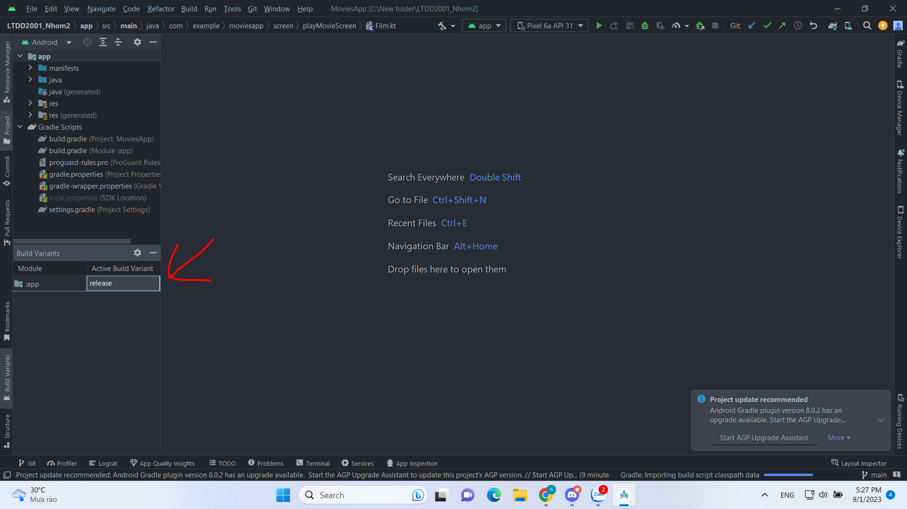

### *Figure I.2.2: How to build app.*

**Step 3:** Choose **to build** on toolbar then select **clean project**

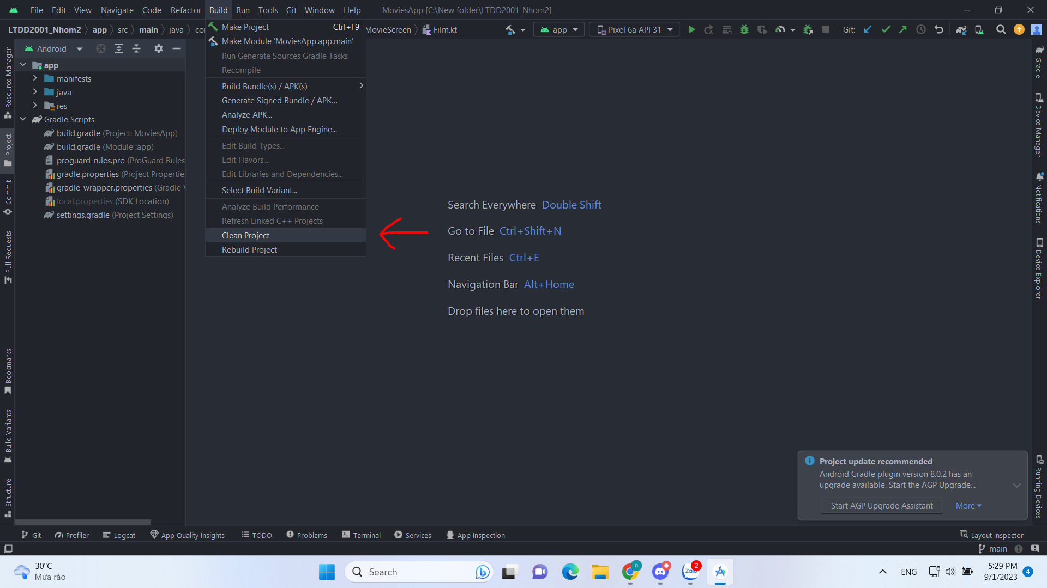

### *Figure I.2.3: How to build app.*

**Step 4:** Choose **Build** on toolbar and select **Build Bundle/APK** the choose **build APK**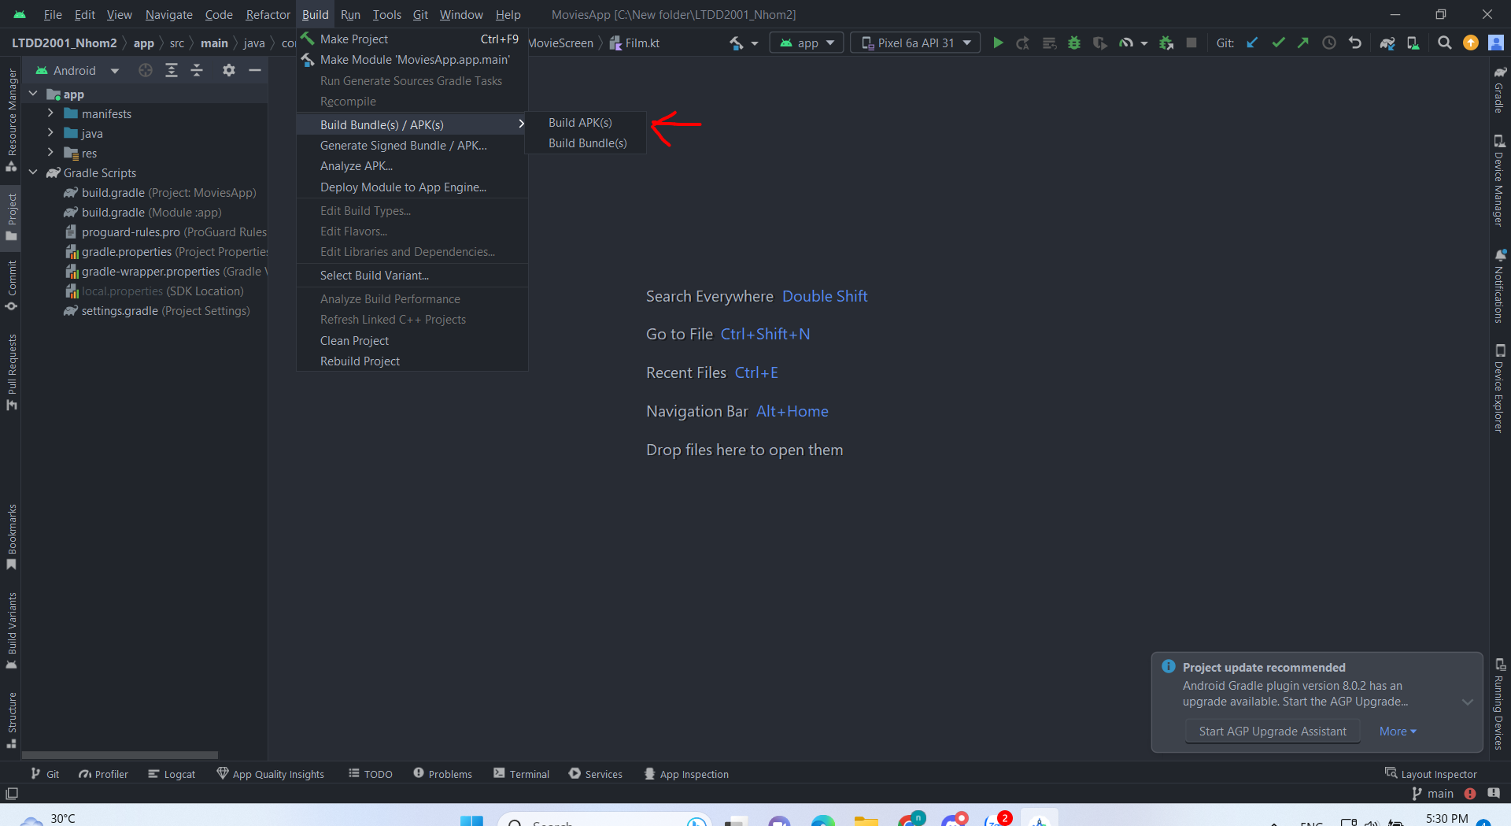

### *Figure I.2.4: How to build app.*

**Step 5:** In build **gradle (Module app)** change path of **storeFile** by navigating to the folder where your project's files are stored, the going to **keystore** folder, obtaining the file path to the "key.jks" file. Afterward, update the path as shown below.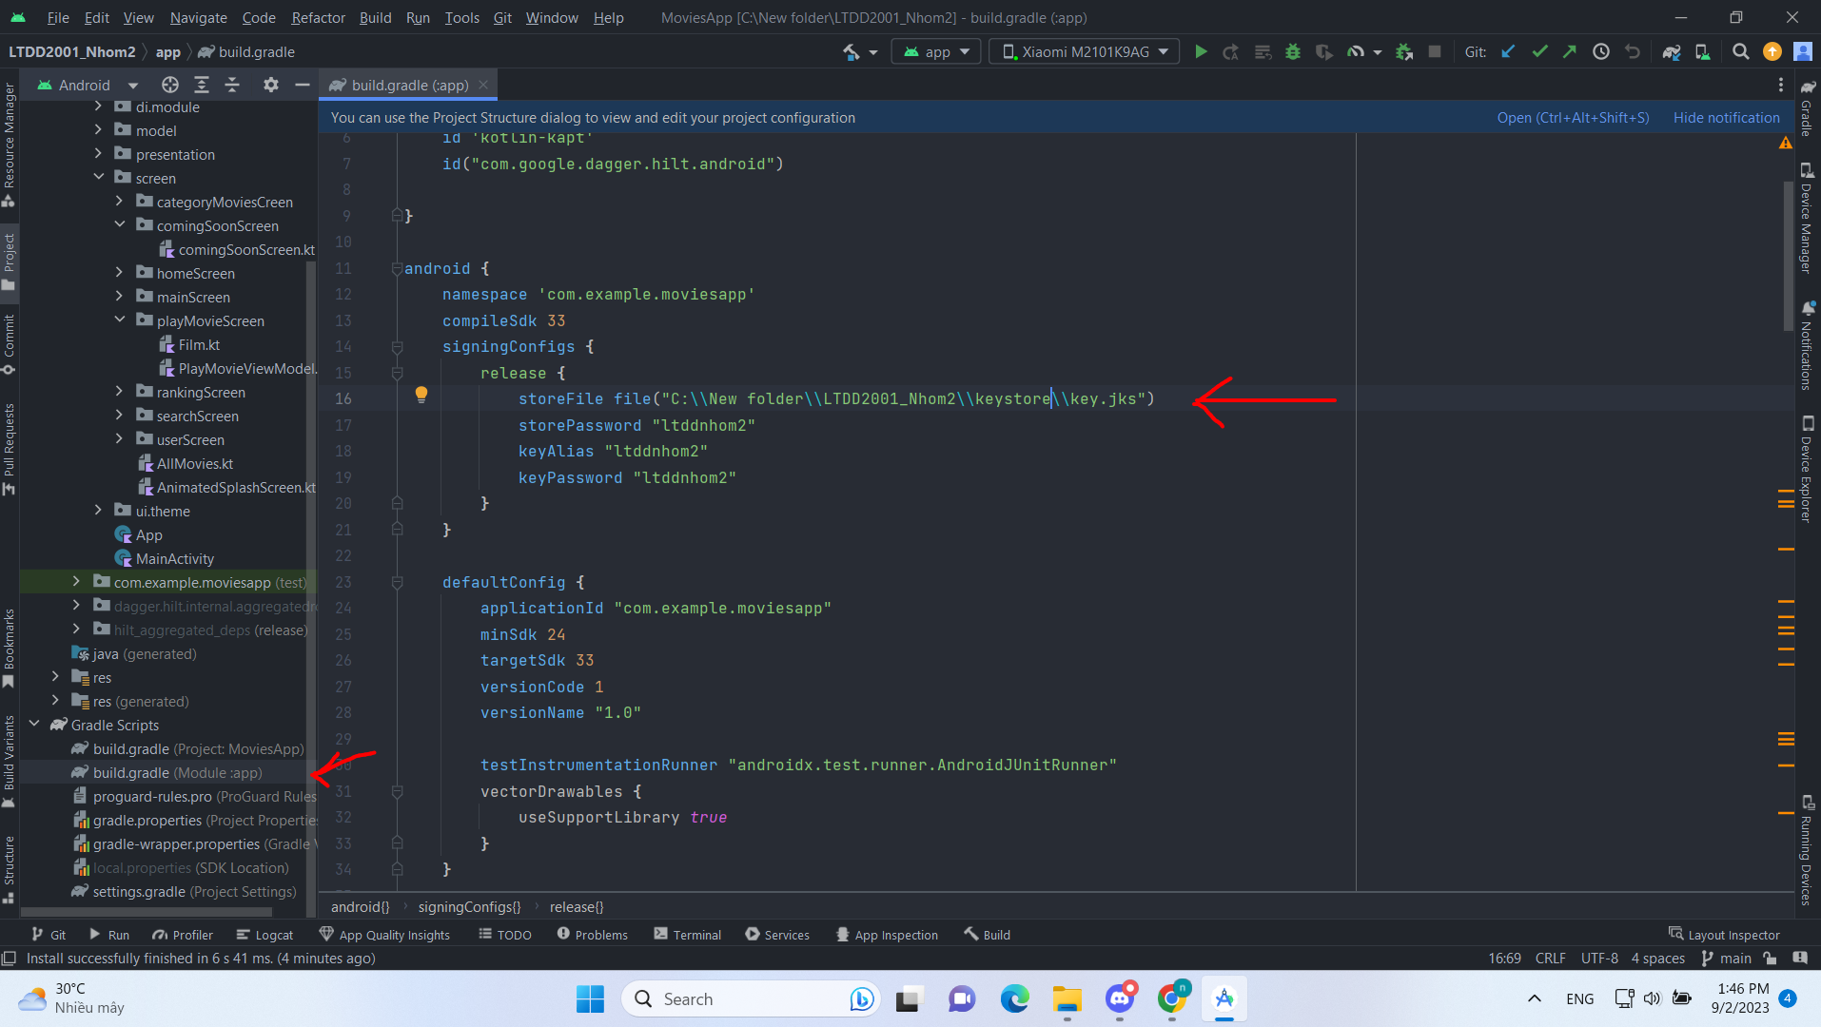

### *Figure I.2.5: How to build app*

**Step 6:** Sync Now project, run app then you can login.

**Notice:**

* **For Google:**

If you don't build a release version, you won’t be able to login with Google and triggering events will have no effect.

* **For Facebook:**

Specifically for Facebook, you need to add **test users** to have the login capability in the app. To make the Facebook login feature public, we must provide proof of our business to Facebook and request login permissions. Therefore, at this moment, we cannot make this feature available to the public. To use it, you must add **test users** in the **Facebook Developer**.

* **Login Gmail**

Use Firebase Auth KTX for Gmail login. [Video demo](https://www.youtube.com/shorts/8Xv_EKVI4k0)

* **Login facebook**

Use Facebook SDK to login by Facebook account!

This is when logging in with Facebook and not yet added to the list of **test user.**

<https://www.youtube.com/shorts/fHXCfHWhWDQ>

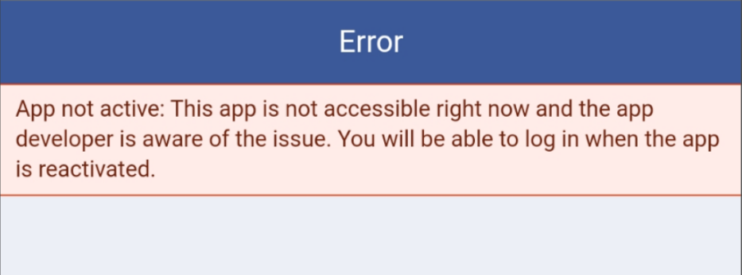

### *Figure I.2.6: Login Facebook Error*

Login when add test user

[Link video demo login trên Youtube](https://www.youtube.com/shorts/fcE_n-69eI0)

The result of data in Firebase Authentication: You can check at  
Tk:[nhom2ltdt@gmail.com](mailto:nhom2ltdt@gmail.com) MK: ltdtnhom2

## 

### *Figure I.2.7: Our team firebase*

**Video Playback Function:**

We utilize the **Media 3 ExoPlayer library** to play videos using the Uri links stored in the database. We've carefully managed the lifecycle of videos within the **ViewModel class**, ensuring that video playback doesn't interfere with the overall application lifecycle.

**Favorite Movie Addition Function:**

We use **UserId** provided by **Firebase** **Authentication** as a parameter to store user-specific data on Firebase. Each time a user logs in, their list of favorite movies is retrieved based on their current **appId.**

This function requires user authentication, so if a user is not logged in, they will be directed back to the login screen to continue.

**Network Connectivity Requirement:**

Using **ConnectivityManager** to manage and check if the app can establish a Wi-Fi/ mobile data connection. If don’t, content screens will not be download and the app will ask the user to establish a network connection to continue.

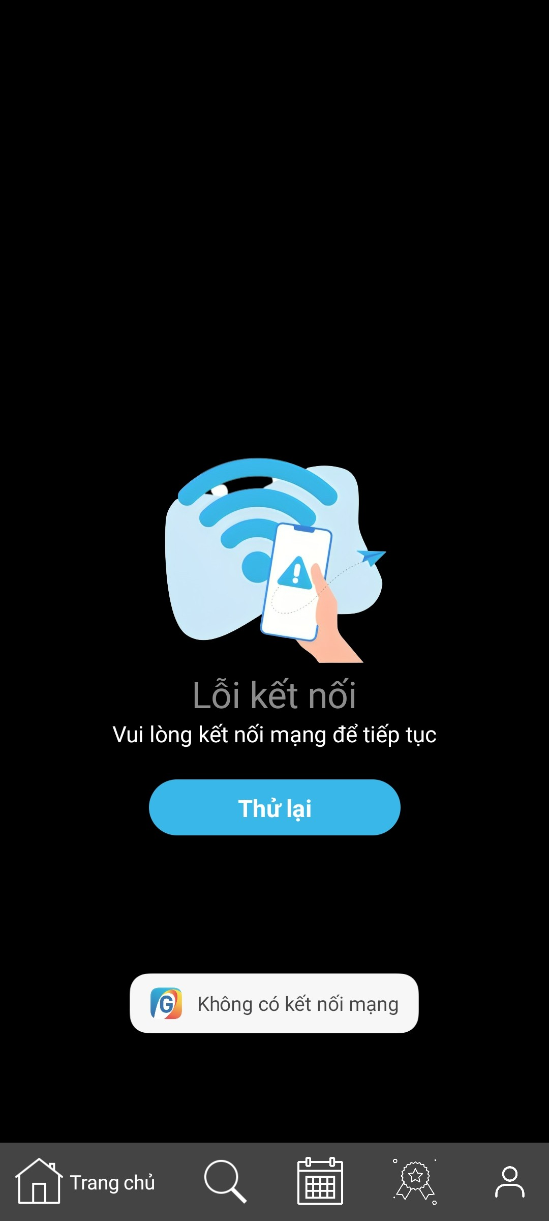

**Notification Sending function:**

Using *POST_NOTIFICATIONS* to request user permission. When app is allow to send notifications,create a channel and use NotificationCompat.Builder to create and sending notifications to users.

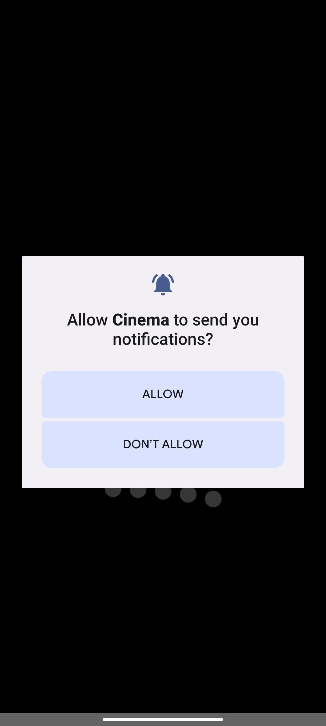 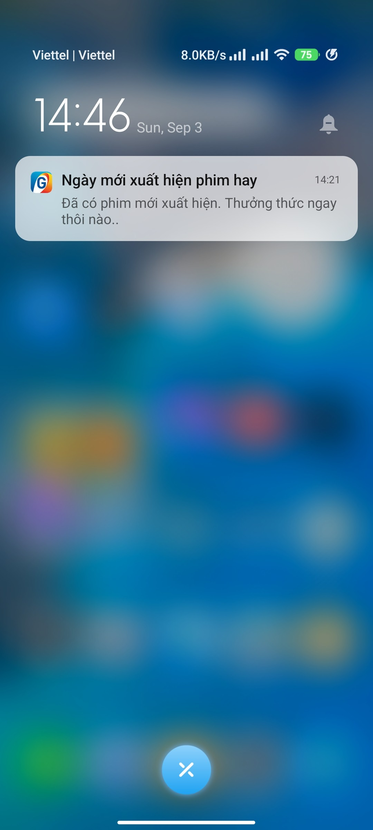

**Notice:**

* **Must connect to network: Wifi/mobile data.**
* **Right now, the app only has 1 link of video, we can change video link in database.**

# 

# 

# **II. DIRECTION FOR USE**

## **Login & Signup account:**

From Home (trang chủ) screen, click on user icon located in the bottom-right corner of the screen to access the User page.

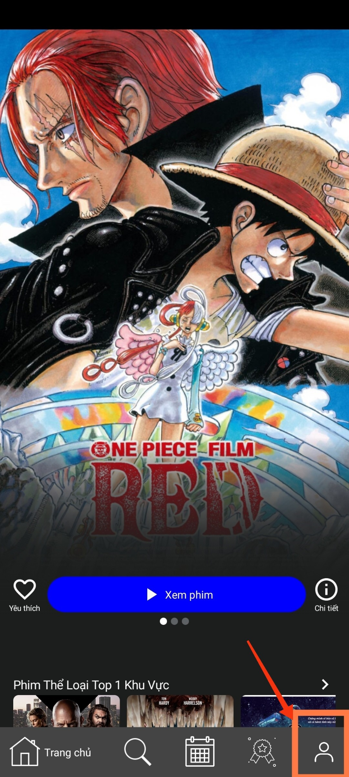

### *Figure II.1.1: How to access User page.*

Then choose **Tiếp tục với Galaxy Play (Continue** **with Galaxy Play)** or **Thiết lập tài khoản (Account Settings)** on below to continue Login/Signup.

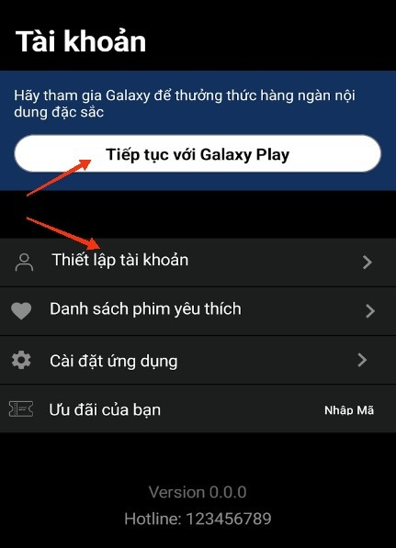

### *Figure II.1.2: How to Login/Signup account*

**Notice**:

If you are not logged in, all persionalization-relate-features in app are all blocked. Logging in is needed to proceed.

Choose the login method that suits you best (please read the login instructions in the **Technical Description and Operations** section above).

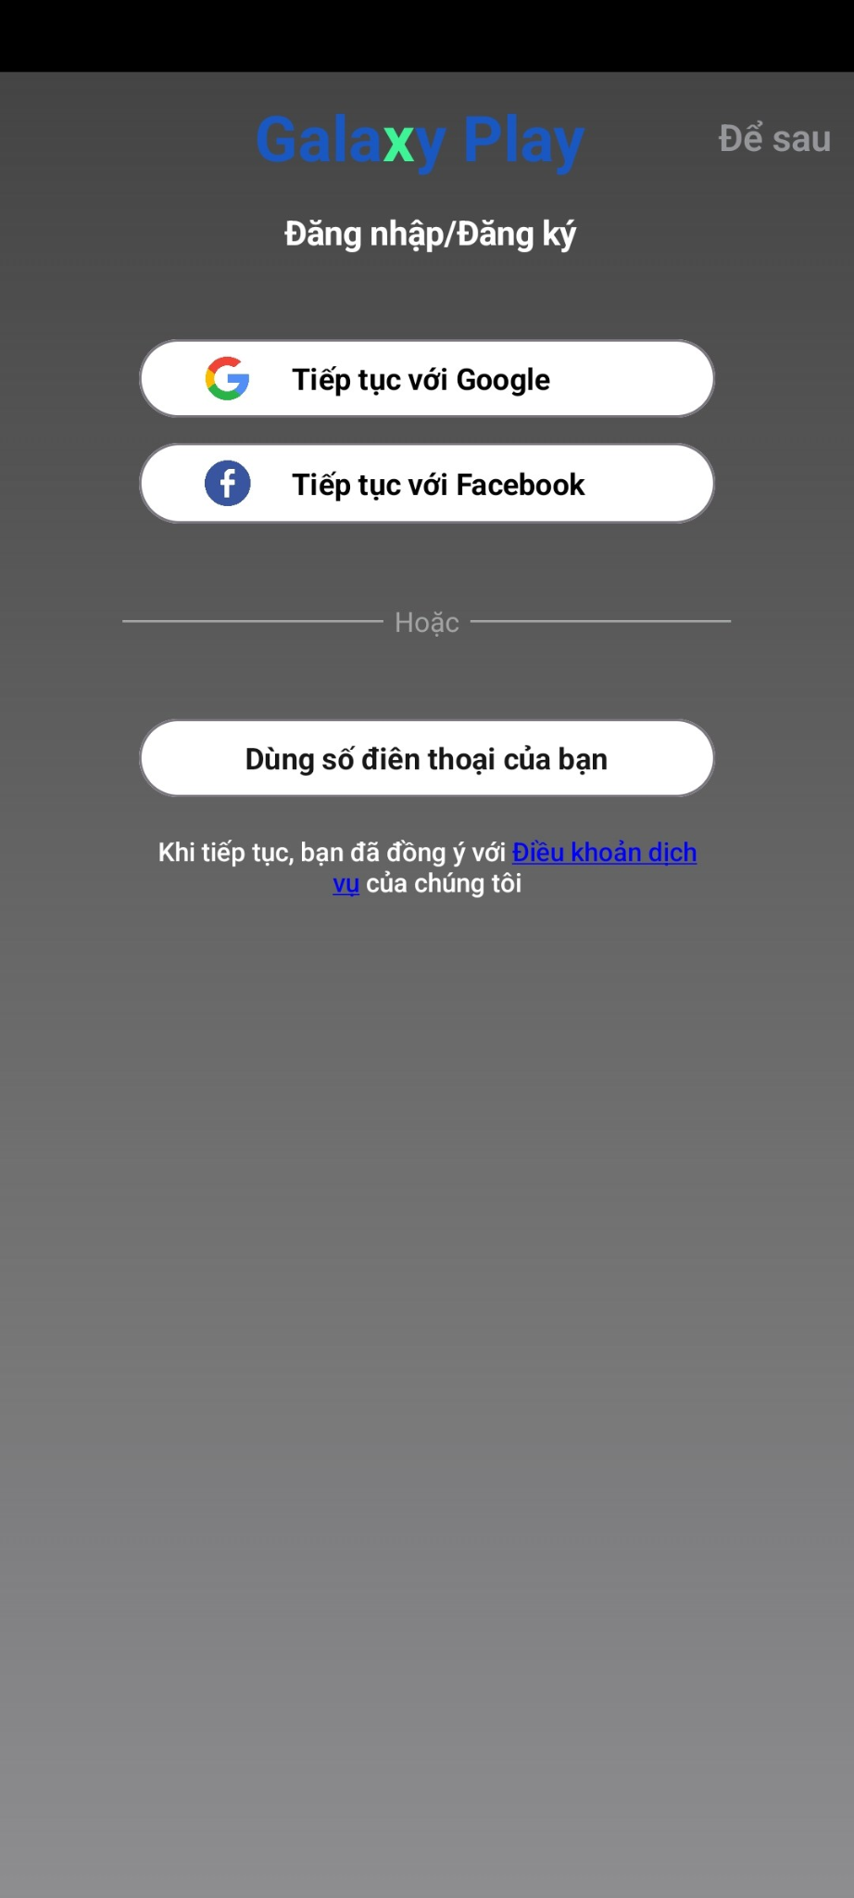

### *Hình II.1.3: Sign in/ Sign up Interface*

Login successfully:

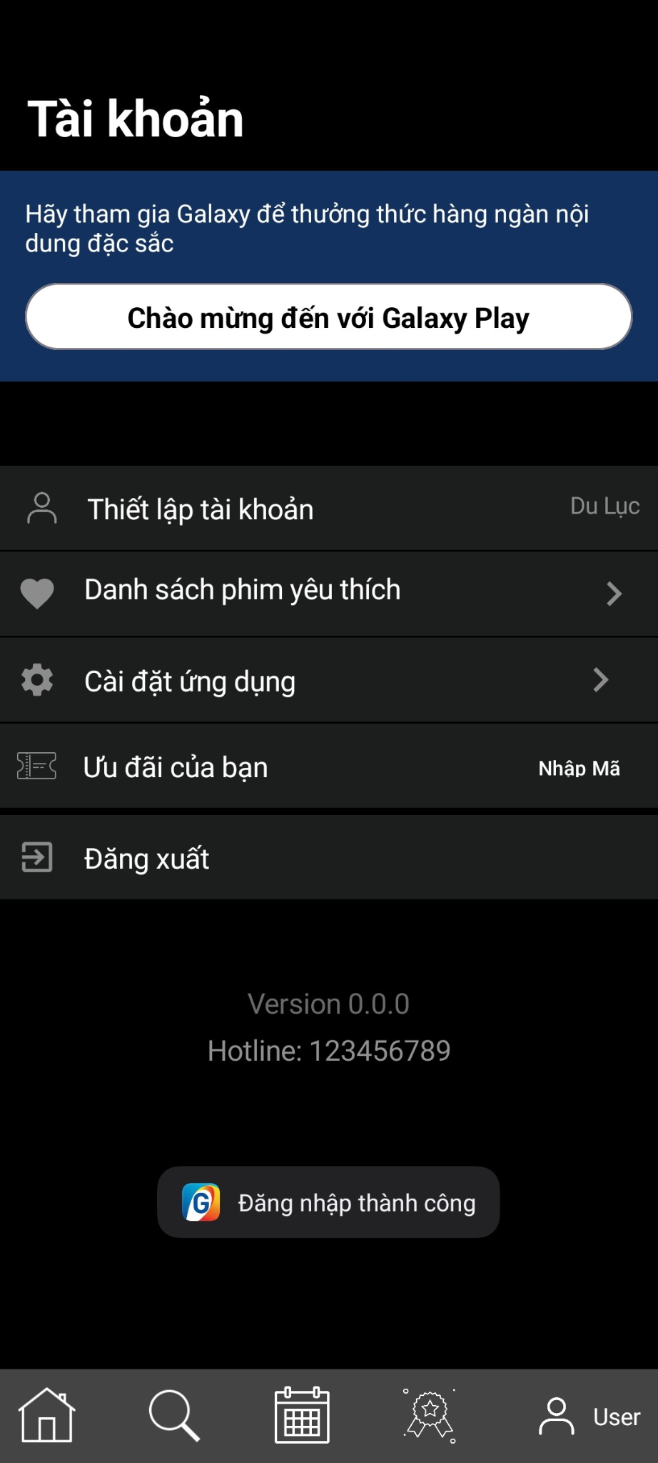

### *Figure II.1.4: When login successful*

If want logout, please click **đăng xuất (Logout)** or **thiết lập tài khoản (Account settings)** => **Đăng xuất (Logout)**

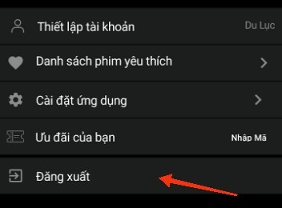

### *Figure II.1.5: Logout*

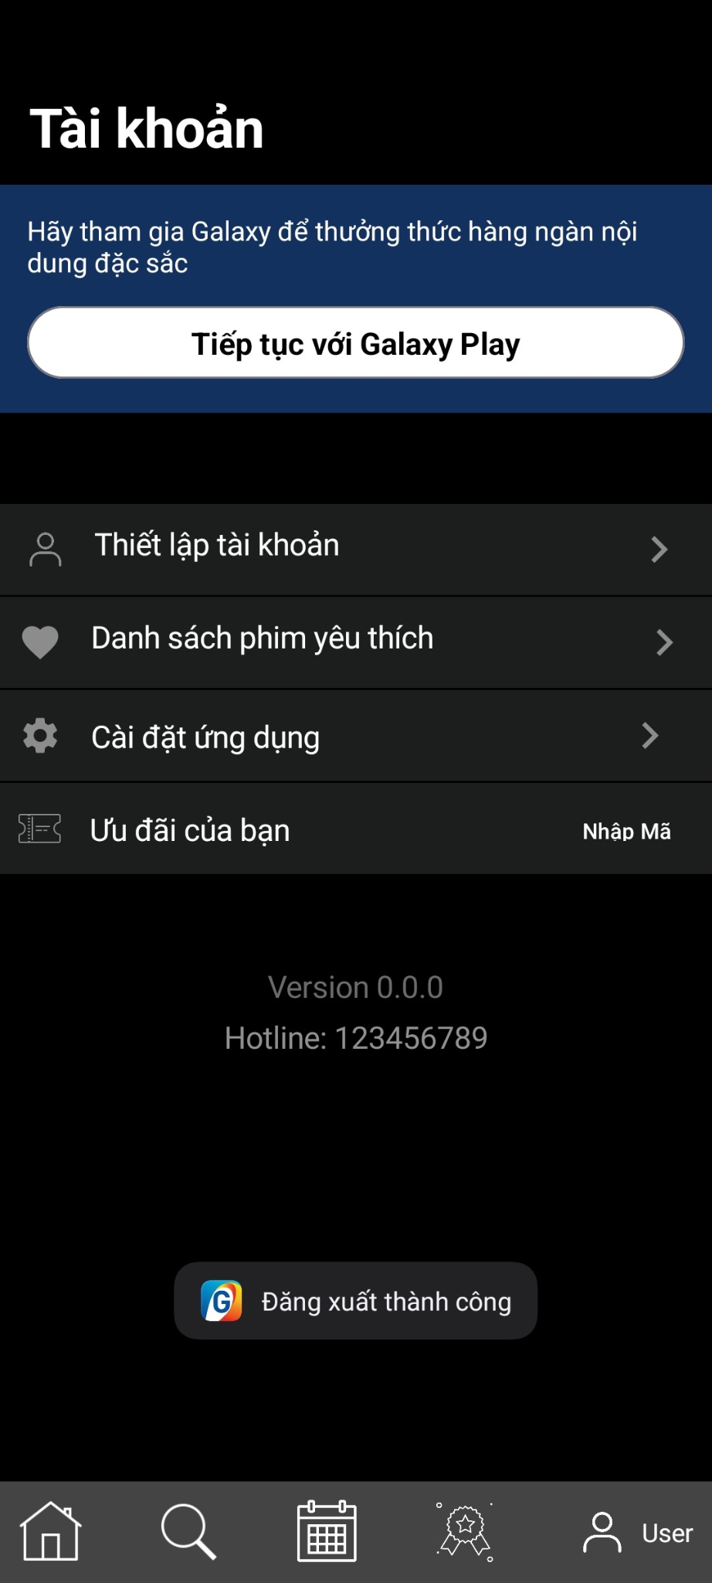

*Figure II.1.6: Logout*

### 

### *Figure II.1.7: User screen when logout successfully*

## **Homepage:**

From the Homepage, we can see the movie genres and some highlighted movies of those genres that will be recommended on the Homepage.

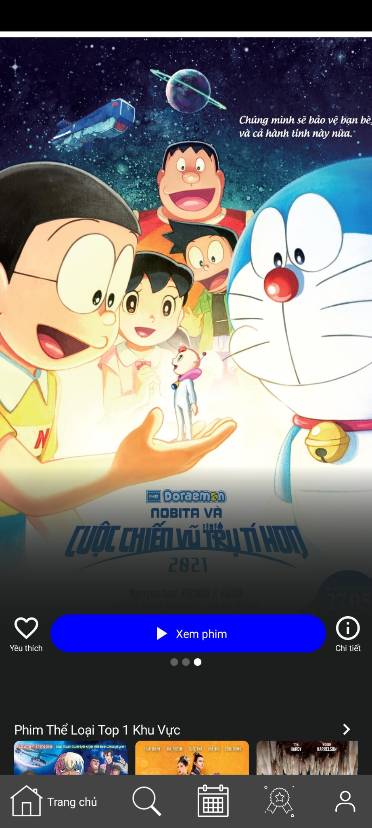

### *Figure II.2.1: Homepage*

This is a carousel to show the featured movies of the month. It will automatically switch to another movie every 4000 seconds to make the app look dynamic, or you can also swipe horizontally.

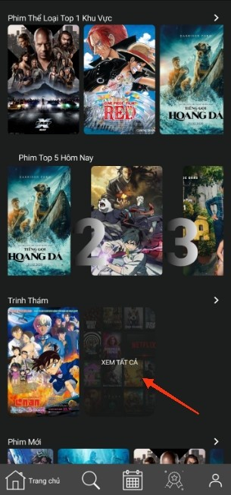

### *Figure II.2.2: Featured movie page*

These are movies categorized into different genres to help users easily browse and choose a movie to enjoy.

Click **View All (Xem tất cả)** or **Add (thêm)** icon to open all movies in that genre.

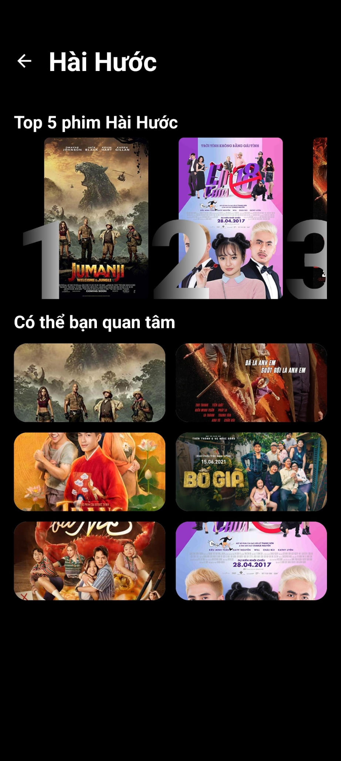

### *Figure II.2.3: Movies on same genre*

## **Searching**

You can access the search feature by clicking on the magnifying glass icon (the second icon) on the navigation bar.

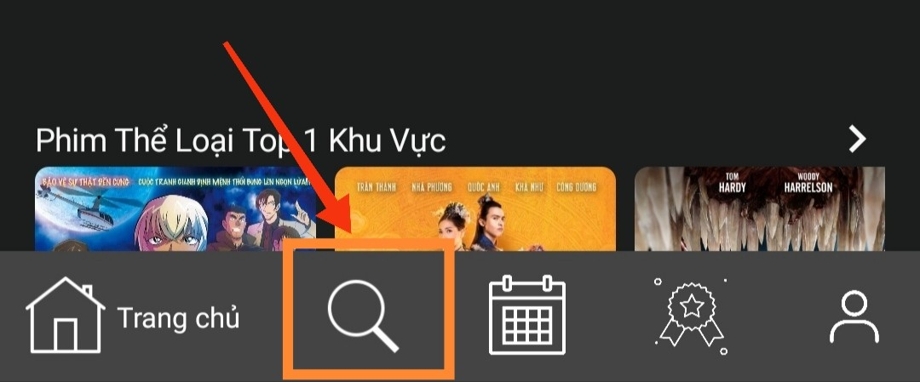

### *Figure II.3.1: How to enter Search*

You can search for the movie you want to watch by entering the movie's name in the search bar or you can search for movies by your preferred genre in the genre section.

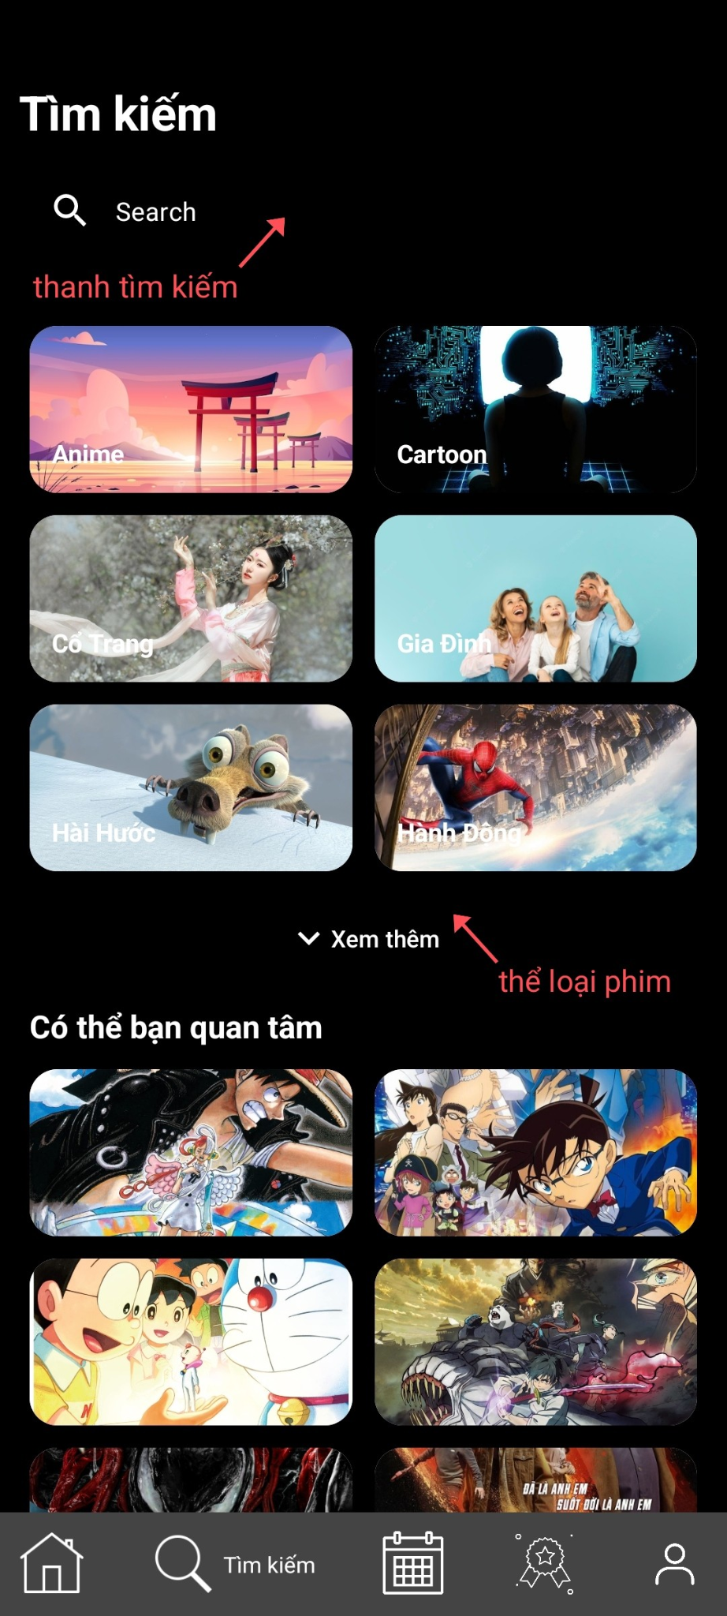

### *Figure II.3.2: how to search.*

With the **search function**, you can find movies by their title, whether in Vietnamese or English.

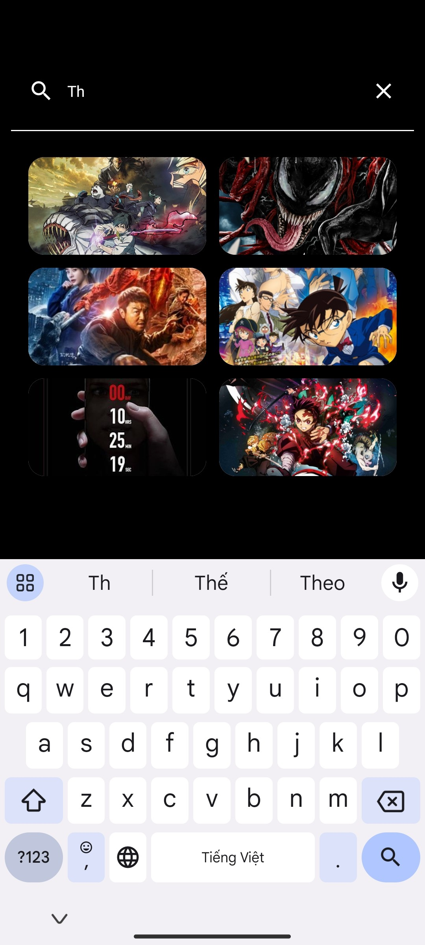

### *Figure II.3.3: Search results in the search bar*

When you select each genre, it will display movies of the same genre. This categorization is very helpful for people who are unsure about which movie to watch or are in the process of choosing a movie that suits them



### *Figure II.3.4: Show movies by theirs genre*

## **Upcoming**

The app also features an **'Upcoming Movies'** function. This feature allows you to explore and get early information about movies that are will be released in the near future. You can view detailed information about these movies, including release dates, cast, directors, and plot summaries.

If you're a film enthusiast, the **'Upcoming Movies'** function will serves as a valuable source of information to make sure you don't miss on any by simply click on the **Calendar icon (the third icon)** on the toolbar to access this feature.

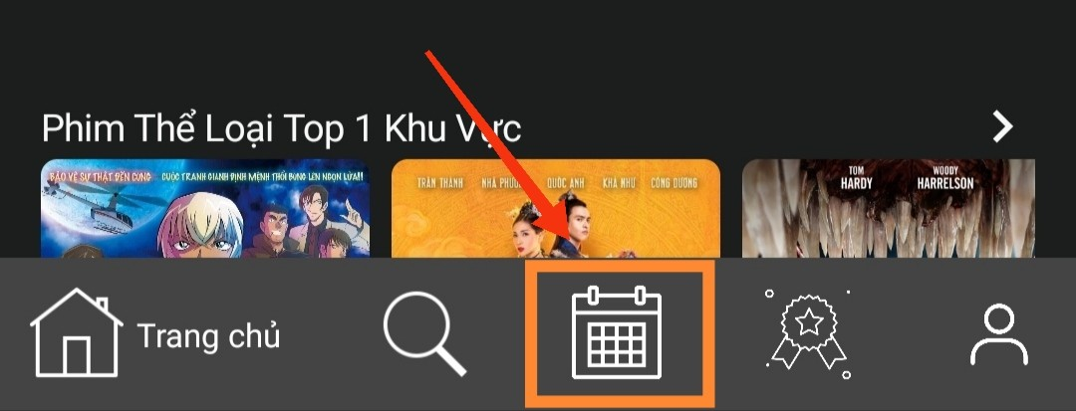

### *Figure II.4.1: How to access Upcoming*

Here you can easily know when movies are released, this will sort based on the released date of the movies.

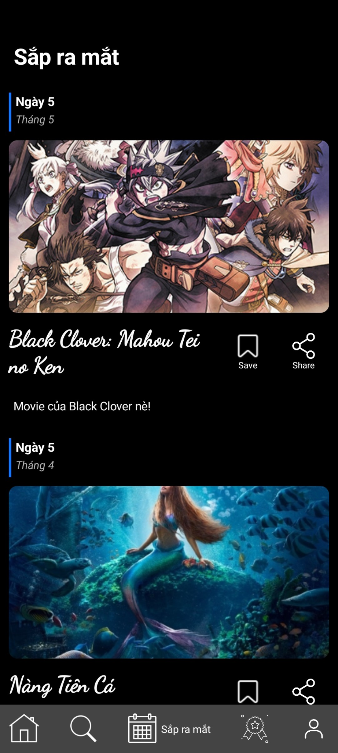

### *Figure II.4.2: Upcoming screen*

You can share these movies with your friends, and everyone can join to waiting ti watch them upon release.

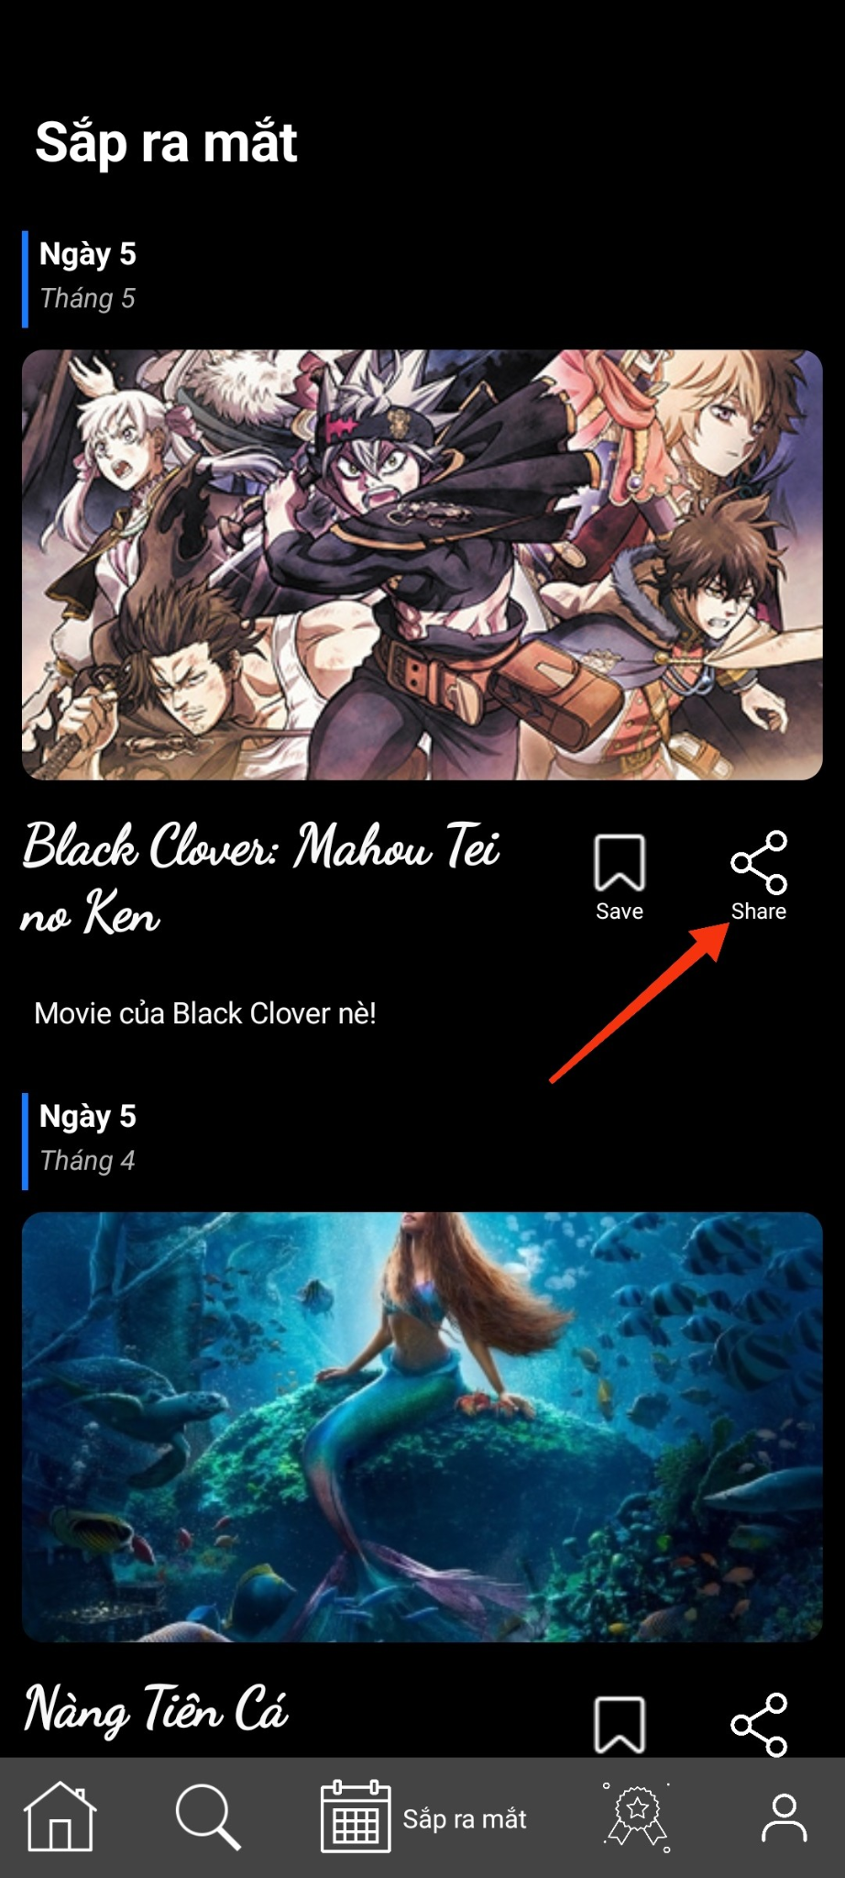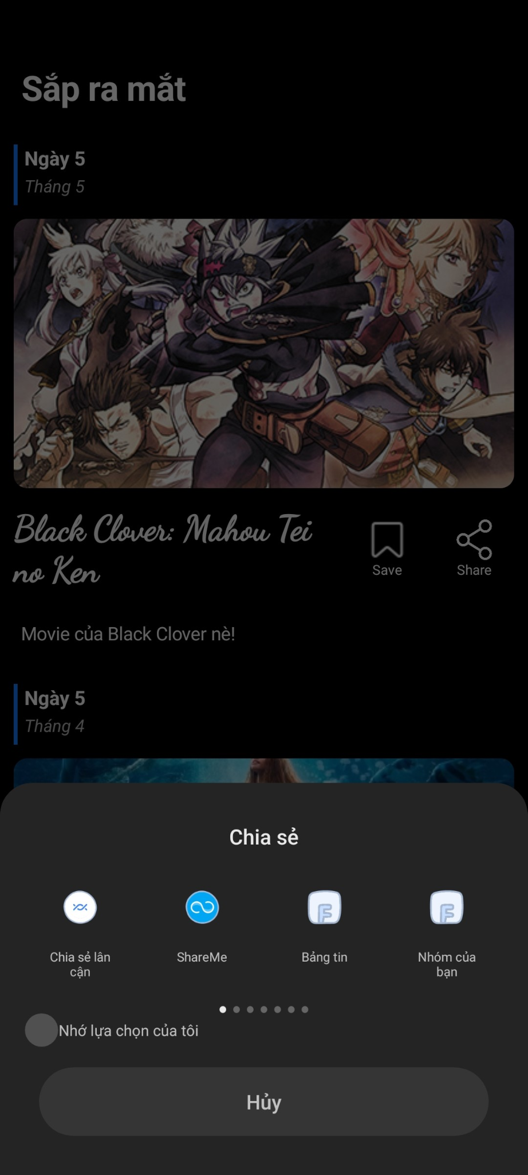

### *Figure II.4.3: How to Share upcoming movie.*

### *Figure II.4.4: How to Share upcoming movie.*

To save the movie, click **Save** icon next to **Share** icon.

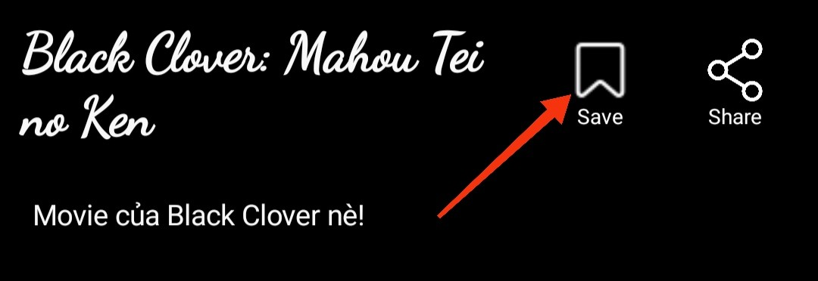

### *Hình II.4.5: Manual to save coming soon film.*

## **Ranking**

To open it click on the fourth icon on toolbar.

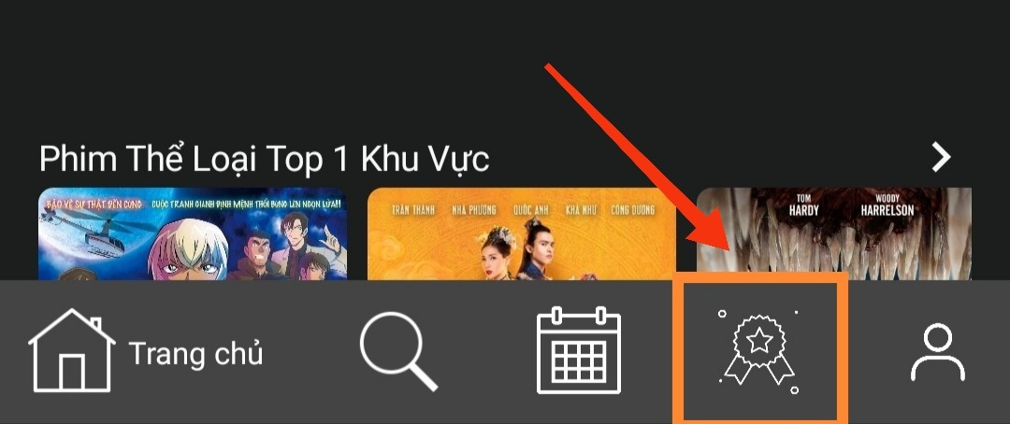

### *Figure II.5.1How to access Ranking screen.*

This is where we rank the list of movies with high views for this month, and you can click on the **Add** icon to add them to your favorites list.

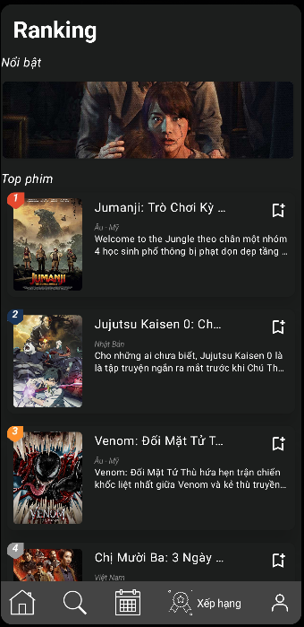 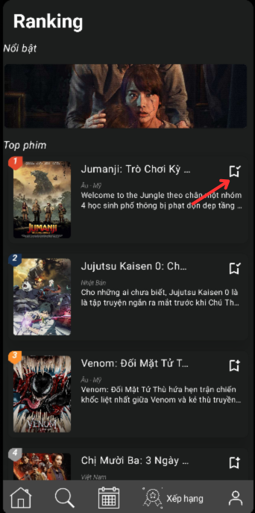

### *Figure II.5.2: Ranking screen*

### *Figure II.5.3: How to save a movie from Ranking screen.*

## **Favorite List**

Saving favorite movies or movies you haven't had time to watch is crucial, which is why this feature was introduced. To use this feature, you must log in first. Our database will store this information so you can use it in subsequent logins or on different accounts. After successfully logging in, you can click on the **Favorite Movies** (**Danh sách phim yêu thích)** list here.

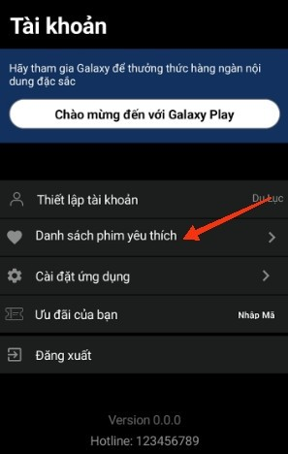

### *Figure II.6.1: How to find your favorite list.*

First, this will be an empty list.



### *Figure II.6.2 Empty favorite list*

Then add some to the list.

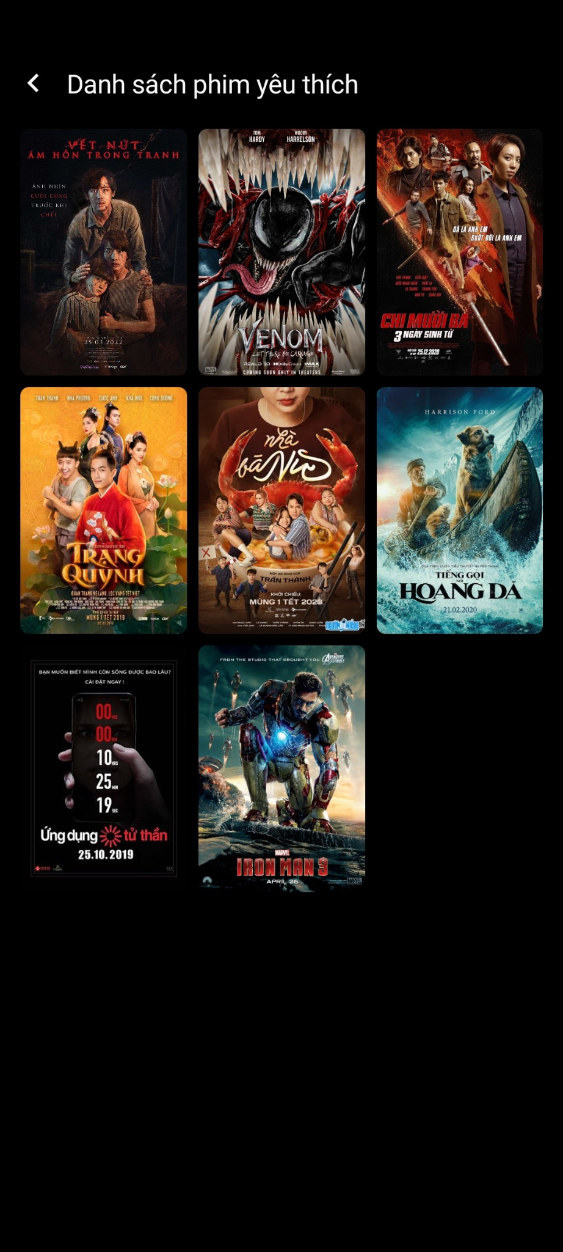

### *Figure II.6.3: List after being add*

## 

## **Watching Movie**

When you click on any movie, you will be taken to the movie viewing page. This is the core feature of a movie app.

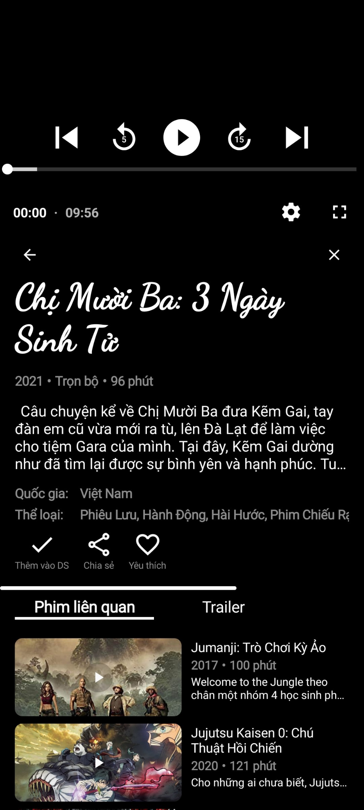

### *Figure II.7.1: This is when you click to watch a movie.*

Here we can see the basic information about the movie including (movie title, genre, country, duration, description, release year, ...).

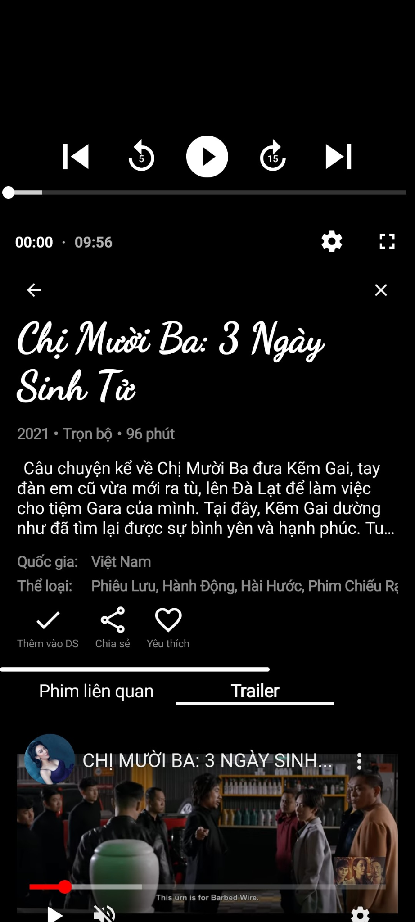

### *Figure II.7.2: The basic information about movie*

In the movie description section, to avoid occupying too much screen space, we limit the number of lines. Click on it to expand if you want to see more.

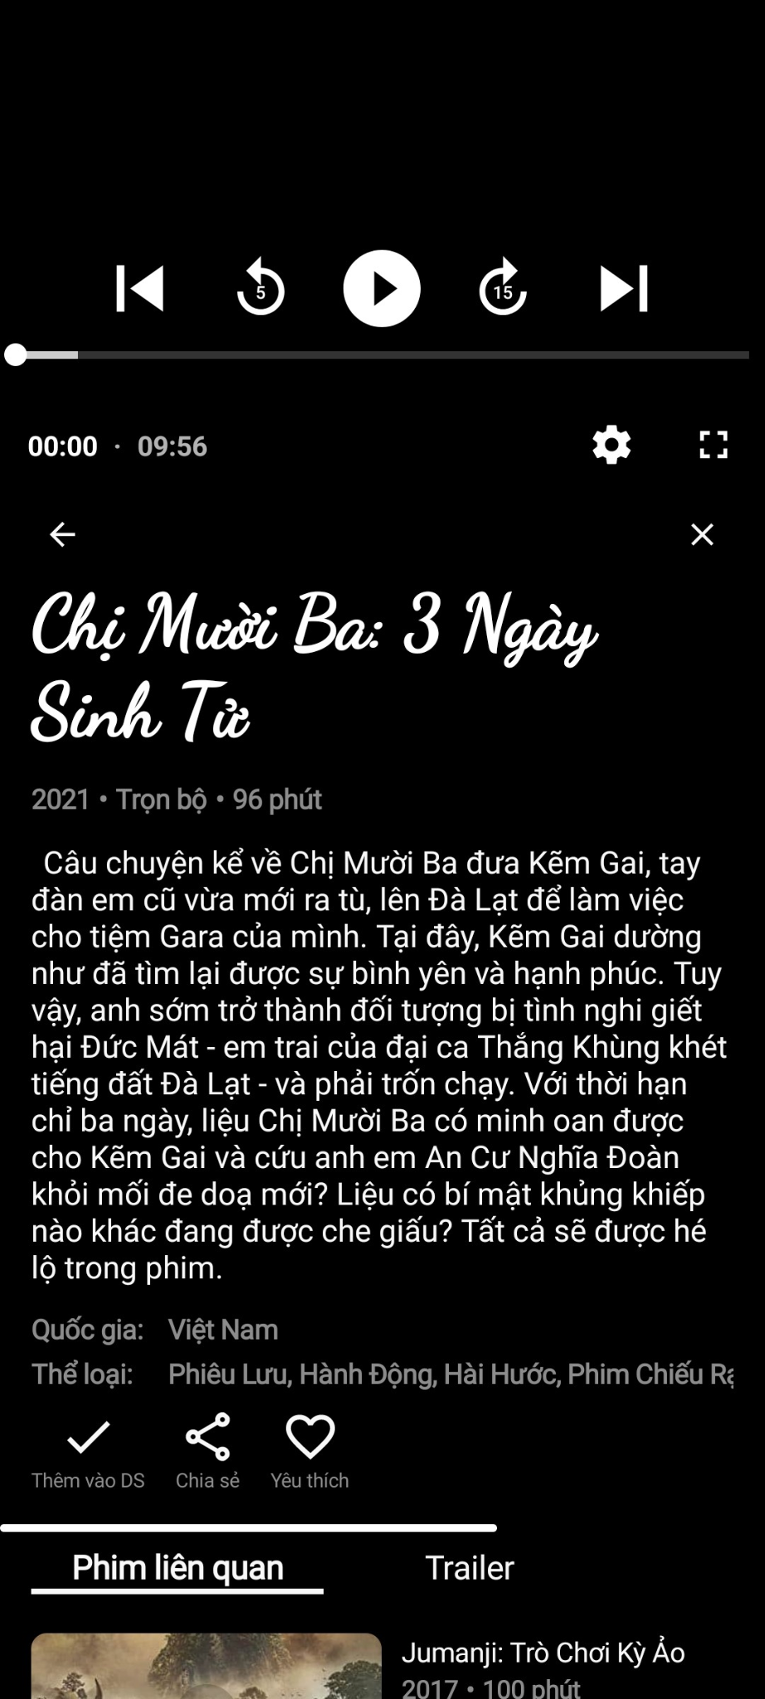

### *Figure II.7.3: The basic information about movie after expanding.*

About genres, a movie can have many genres:

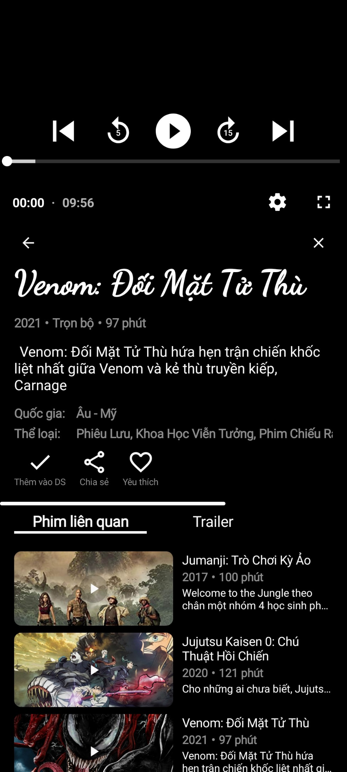

### *Figure II.7.4: Movie’s genres*

Swipe to see more:

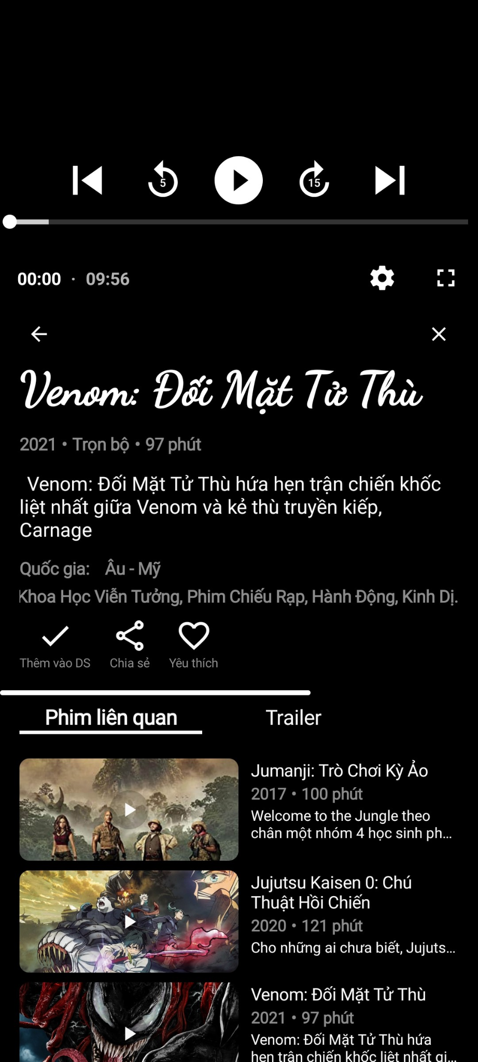

### *Figure II.7.5: Swipe to see more genres*

The features to save movies to your favorites list (must be logged in), share movies, and mark them as favorites.

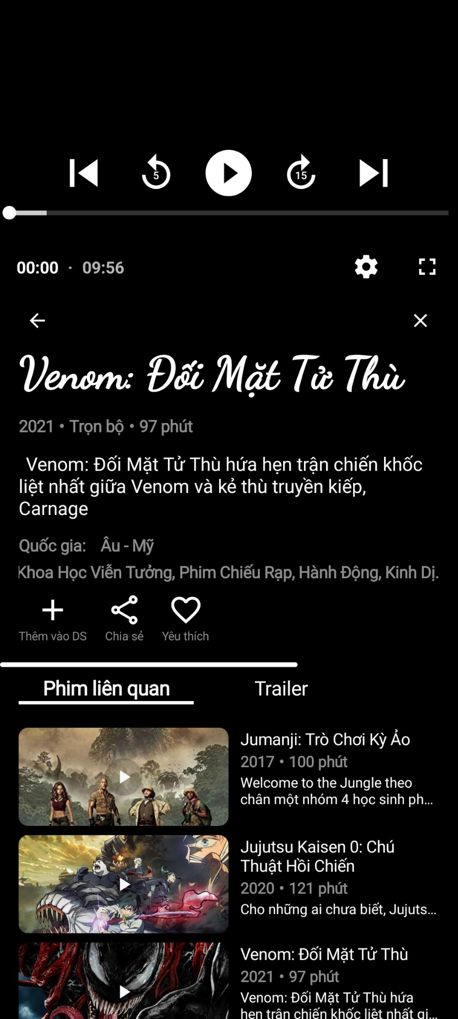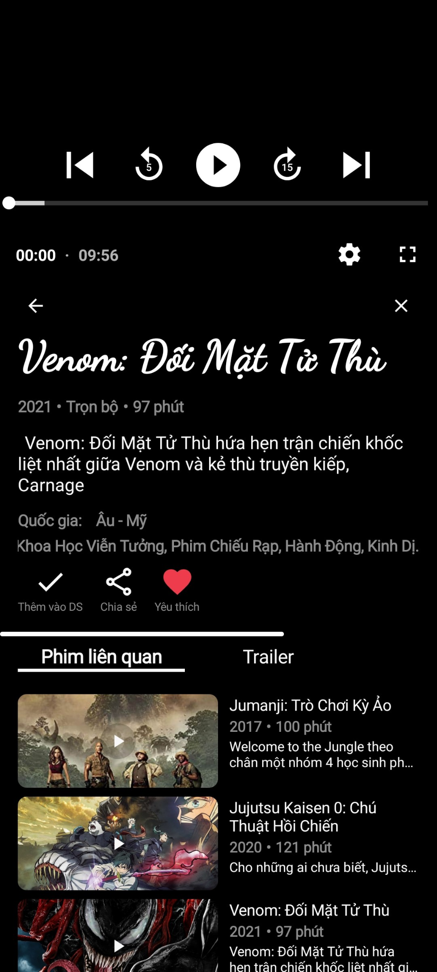

### *Figure II.7.6: Save, Share, add to Favorite list features.*

### *Figure II.7.7: Save, Share, add to Favorite list features.*

Or you can share to your friends by **Share** feature**:**

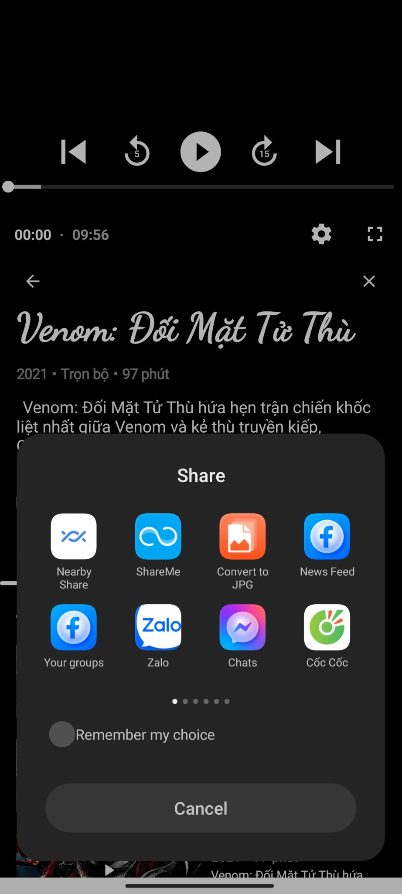

### *Figure II.7.8: Share*

The **related movies tab (Phim liên quan)** displays options related to allow users to continue watching when they want to find movies with the same theme

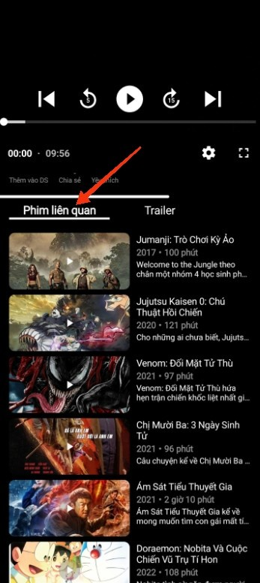

### *Figure II.7.9: The related movies*

Especially, with the trailer tab, you can preview trailers on YouTube right within the app. This provides excitement and anticipation before starting to watch a movie It helps you decide whether it suit for ou or not, especially when you're too lazy to read the description or the description isn't satisfied you.

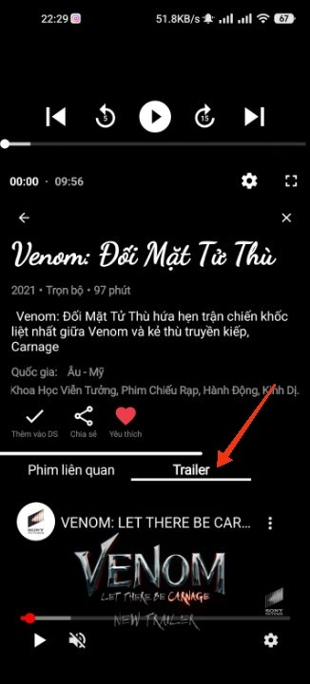

### *Figure II.7.10: Trailer*

Here, there are also some additional customization options that YouTube provides for you to set according to your preferences.

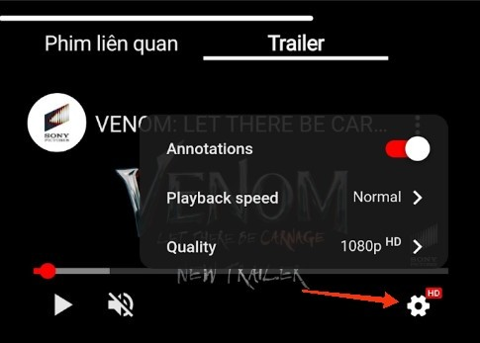

### *Figure II.7.11: YouTube customization options*

Finally, there's a player for watching movies, it has the basic functions of a player **(pause, play, rewind 5s, fast forward 15s, customize playback speed and audio quality, full-screen viewing mode)**.

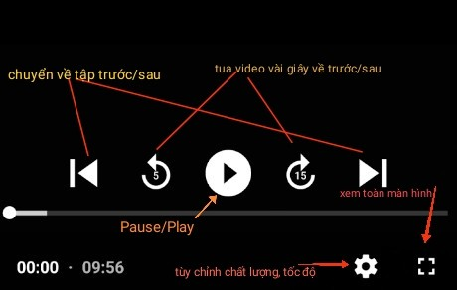

### *Figure II.7.12: Player basic funtions*

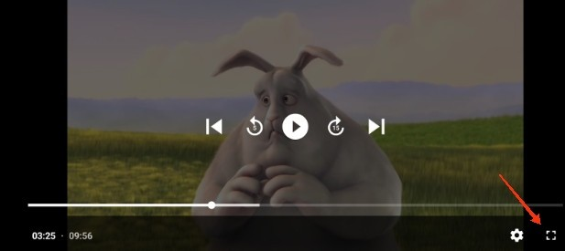

### *Figure II.7.13: Fullplay mode*

# **III. SHORTCOMINGS AND APPLICATION DEVELOPMENT DIRECTIONS**

As our first application and due to time shortage, our application still has several shortcomings. However, we have figurited out the issues and will complete it when we have chance in the neat future.

**Shortcomings**

1. **Limited Movie Selection**: We haven’t found way to insert URLs stored on clouds to use as databse for the app, only can play limit URLs.
2. **Login/Signup**: This is not yet fully developed. Specifically, Facebook we need to add user accounts and register as a Facebook developer to enable login
3. **Settings Functionality**: The settings feature has not been implemented yet. We plan to add features such as theme customization, notifications, and subtitles.
4. **Movie Organization:** We haven't done yet, it can’t be able to increase the view count when watching
5. **Movie search:** We plan to expand the search function to include searching by director or actor and implement natural language processing.
6. **Notifications**: this has not completed yet, We plan to send notifications to users when new movies are added,...
7. **Database Organization**: Currently, including viewing, editing, and deleting, requires manual job.03/09/2023

# **IV. LIST OF TEAMS AND ASSIGNMENTS**

|  |  |  |
| --- | --- | --- |
| **MSSV** | **Full name** | **Assignment** |
| 2051010201 | Hoàng Quảng Ngà | Logic processing, login/registration, search page, user page, player, Firebase. |
| 2051012061 | Phạm Đức Mạnh | Ranking page, notifications, write a report in English. |
| 2051012083 | Bùi Văn Nin | Home page, movie viewing page, favorite movie list, network connection. |
| 2051010304 | Lê Thị Ngọc Thư | The coming soon page, sharing feature, database, write a report in English. |
| 2051012105 | Mai Nhật Thanh Tâm | Splash screen, database, write a report in Vietnamese. |

#### *Table IV.1: Tables assignment*

# **V. SUMMARY**

After a period of research and study in Android programming with Jetpack Compose, our team, under the guidance of our subject lecturer, Professor M.S Le Ngoc Hieu, has successfully developed the application and reported on the topic "Building an Online Movie App."

During the research, our team gained a deeper understanding of this field and a greater insight into the subject matter. Besides enhancing our knowledge and experience, this project also improved our teamwork skills. Throughout this journey, we have put in our best effort to deliver the best possible project, although there are still some remaining imperfections.

We sincerely look forward to receiving your contributions, feedback, and guidance, which we highly value.

Thank you very much!